Project Title:
Diabetes probability based on behavioral, medical, demographic, and economic factors.

Background Information & Problem Statement:
Nearly 10% of Americans have type II diabetes (CDC), costing each nearly 10 years of their life, and the U.S. over $325 billion dollars, annually. The American Diabetes Association (ADA) states that “Care for people with diagnosed diabetes accounts for one in four health care dollars in the U.S.” We seek to identify behavioral and societal diabetes risk factors to improve health care programs, lower the U.S.’s healthcare burden, improve the private sector’s productivity, and improve U.S. citizens’ wellbeing.

Business Justification:
The ADA declares that "The total estimated 2017 cost of diagnosed diabetes of $327 billion includes $237 billion in direct medical costs and $90 billion in reduced productivity. […] People with diagnosed diabetes incur average medical expenditures of $16,752 per year, of which about $9,601 is attributed to diabetes. On average, people with diagnosed diabetes have medical expenditures approximately 2.3 times higher than what expenditures would be in the absence of diabetes."
Understanding the main factors which may lead to a diabetes diagnosis is paramount to our society’s survival. For citizens, this means extending their life expectancy, avoiding nearly $10k in diabetes associated costs per year, and enhancing their health. The private sector could save $90 billion dollars from improved productivity, reduced absenteeism, and reduced insurance costs. Governments could re-allocate ¼ of all health care dollars to solving other crises or reduce taxes to reflect reduced health care needs.

Academic Research Paper Review:
Social Determinants of Health and Diabetes: A Scientific Review explores the impact of socioeconomic status (SES) on diabetes onset and progression, highlighting the importance of social determinants of health in shaping health outcomes. The prevalence of diabetes is higher among individuals with lower income and educational levels. The neighborhood environment and food insecurity also significantly influence diabetes outcomes. The article also emphasizes the importance of health insurance in accessing diabetes screenings and care and the substantial cost burden associated with diabetes care. Investigating the impact of the cost of living on diabetes occurrence is crucial, given the high healthcare costs and the increased risk of undiagnosed diabetes among uninsured individuals. The life-course exposure to resource-deprived environments also contributes to disparities in diabetes risk, diagnosis, and outcomes.
Epidemiology of Diabetes and Diabetes-Related Complications provides an overview of the state of Diabetes, the types of diabetes, the non-modifiable and modifiable risk factors, and a review of co-morbidities and associated healthcare costs. Notably, the work underscores the lag in diagnosis and the number of people who may go undiagnosed: for every 10 diagnosed with diabetes, there is an estimated 3-4 who go undiagnosed. Similarly, there is a large proportion of the population described as pre-diabetic. This 25% of the population described as pre-diabetic is critically important to understand and of interest for further research. Much like other articles and papers we’ve reviewed, modifiable risk factors include diet and physical activity, and non-modifiable risk factors include age, race, family history, and low birth weight.

These research studies and reviews have been considered in our data and variable selection for this work.

Datasets:
- CDC - 2021 BRFSS Survey Data and Documentation.
BRFSS dataset includes behavioral, medical condition, and demographic data. More on the background of the BRFSS survey can be found here.
- Cost-of-living index
The 2022 Annual Average Cost of Living table has the Cost-of-Living Index and Grocery, Housing, Utilities, Transportation, Health, and Misc. values for US states.
- US Populations by State
The 2023 US Population table contains information about 2023 population, 2022 population, Growth and Density Per Miles.

Approach, Progress, Initial Findings:
Data Processing & Cleaning:
CODEBOOK REVIEW: To have a better understanding of the variables in the BRFSS dataset, the Codebook Report was reviewed. The original dataset has 438693 rows and 303 columns.
Diabetes is classified as Yes(1), Yes, but female told only during pregnancy (2) No, and No, pre-diabetes, or borderline diabetes (3). We transformed the diabetes column and created our binary column with the Yes values (1) qualifying as having diabetes (1) in our data set.
HANDLING MISSING VALUES: We did not impute missing values as the data is individual level healthcare inputs. Variables with more than 15 % missing values and non-relevant variables as informed by academic research are excluded. The data was then reduced to 124 columns. After re-plotting the missing values, we removed the rows with NAN value. This reduced our row count to 289,330.
INITIAL VARIABLE REDUCTION: To select the variables for initial modeling, we used Lasso, PCA, correlation and the risk factors for diabetes according to our literature review. We analyzed multicollinearity, using 0.70 as threshold. After selecting the variables and the unique values for each one, the response with ‘don’t know’ or refused to answer are excluded from the analysis. Other variables were transformed in this process for efficiency in analysis including children at home and others.
FINAL DATA: After cleaning, the BRFSS dataset has 22 columns and 134702 rows. The final variables include state, race, gender, general health, physical activity, employment, children at home, alcohol consumption, health insurance, BMI, age, blood pressure, education, income, among others. 12.8% of respondents in our cleaned dataset have diabetes.
We have added the state code and state population in the cost of living data and merged it with our cleaned BRFSS data to form our final dataset.
Exploratory Data Analysis:
VARIABLE ANALYSIS: Before starting the analysis, columns were renamed. Variables Description and values can be found in Table 1 in the Appendix. We examined how variable distribution varies between those diagnosed with diabetes and those who are not with summary statistics, correlation, bar charts, and box plots.
INITIAL DATA LINKS: We found diabetes can be linked to various factors such as race, body mass index, physical activity, and others. Figure 1 shows the correlations between variables, where no two pairs of predictors are significantly correlated. Figure 2 shows four bar charts between predictors and diabetes variables. Other bar charts can be found in our GitHub repository. The bar charts show that variables have a broad distribution. Some of the variables including gender, children, and health insurance show minimal differences with diabetes.

Relationship between Cost of Living and Diabetes:
From the graphs Fig4 – Fig 8, there is a clear trend that the states with a lower index for Cost of Living, Groceries, and Housing tend to have a higher ratio of diabetes. Our hypothesis is that prevalence has been rising more rapidly in low- and middle-income areas, accounting for this ratio. Home environment, unhealthy behaviors, obesity, stress, and medication accessibility are a few risks contributing to a higher incidence of diabetes among low-income households.

Initial Modeling:
We have begun the modeling process ahead of schedule with logistic regression, KNN, Naïve Bayes and Tree classification. For each, we’ve created training data with 80% of our final data set and testing data with the remaining and used all variables to predict the diabetes diagnosis. For KNN, we have selected K=20. We have predicted outcomes for the testing data for each model and run AUC. Currently, logistic regression performs best with the highest AUC value of .84. This initial modeling is promising, and we hope further optimization will only improve this score and prove valuable for those with an opportunity to cure and manage diabetes in the United States.
AUC value for Naive Bayes Classification: 0.706038759926137
AUC value for Tree Classification: 0.622393431533272
AUC value for KNN Classification: 0.675140340185389
AUC value for logistic regression: 0.842269741051964
Next Steps:
Final Model Tweaking, Graph Building, Analysis, and Recommendations:
Our next steps in this process are to review the significant variables within the logistic regression model for a final variable inclusion decision. From there, we will re-run the model in hopes of optimizing further. Then, we will analyze the variables that are most related to receiving a diabetes diagnosis and provide recommendations to groups likely to benefit from this information. Included in this step will be refining graphs, research review, and recommendations for further exploration.
Timeline:
We are working ahead of schedule, having completed our initial modeling and model comparison.
Project Task | Status | Start | End | Notes
Brainstorm topic, find data, speak with Akshay, create proposal | COMPLETE | 2/17 | 3/11
Article Review | COMPLETE | 3/10 | 3/15
Data Cleaning | COMPLETE | 3/15 | 3/20
Project Plan Video Presentation | COMPLETE | 3/18 | 3/26
Preliminary Data Modeling | COMPLETE | 3/20 | 4/2 | Ahead of schedule
Compare & Develop models | COMPLETE | 3/25 | 4/10 | Ahead of schedule
Tune final model | Next | 4/3 | 4/8
Analyze variable relationship | Next | 4/6 | 4/10
Create Final Report | Next | 4/9 | 4/16
Create Final Video Presentation | Next | 4/15 | 4/19

APPENDIX:
Figure 1: Correlation Matrix
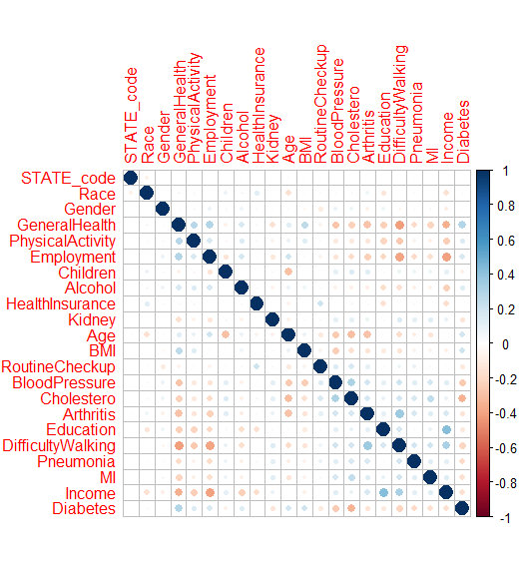

Figure 2: Histogram charts between State Code, Race, Gender, General Health vs Diabetes variables
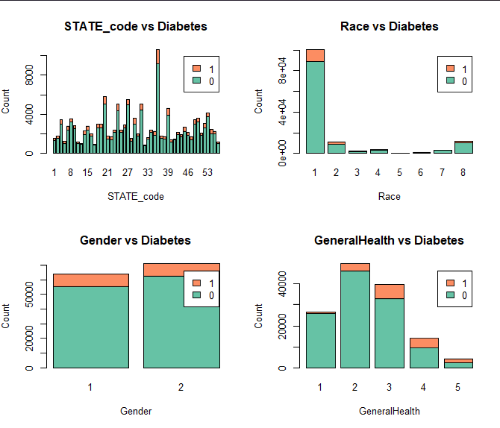
This figure shows the proportion of each state, race, gender, and health status with diabetes. Initial takeaways include those that describe their health as excellent have the least diagnosed diabetes and those who identify as black only and Hispanic have more diagnosed diabetes.

Figure 3: US Population by States

Figure 4:8 Intro:
The following charts plot the density of diabetes with the cost of living index (average at 100). This is represented as number with diabetes divided by the density of the state. The density is calculated by the population divided by size of the state. From the plots, we see that Montana, South Dakota, Nebraska, Kansas, New Mexico, Wyoming, and North Dakota generally have the highest density of diabetes and generally have lower associated costs. Whereas New York and Massachusetts and California typically have lower density of diabetes with higher cost of living.
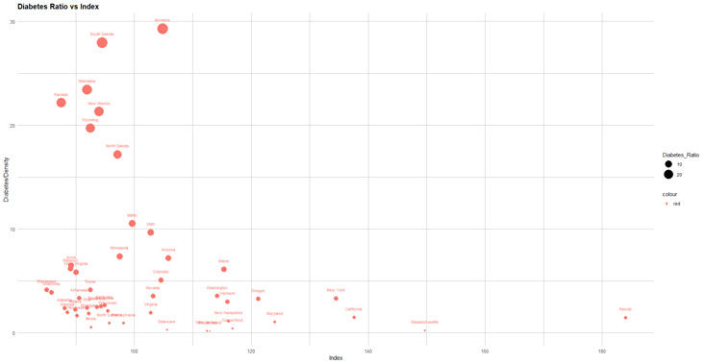
Figure 4: Graphs between Diabetes Ratio vs Cost of Living Index Figure 5: Graphs between Diabetes Ratio vs Grocery Index
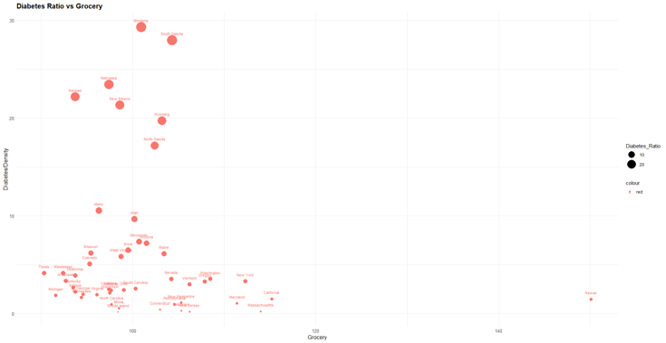

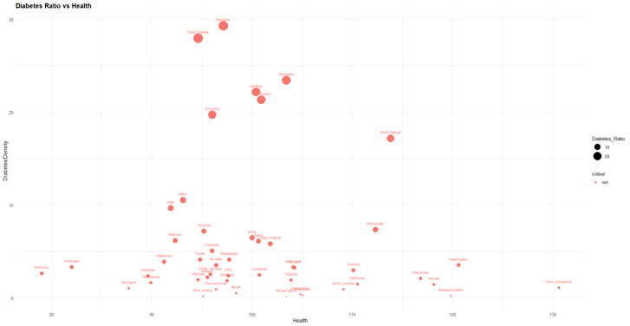
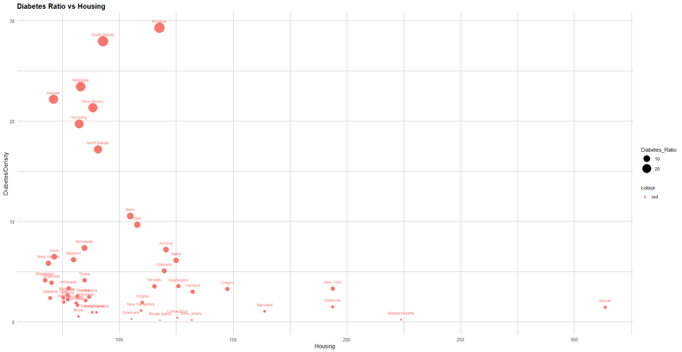
Figure 6: Graphs between Diabetes Ratio vs Health Index Figure 7: Graphs between Diabetes Ratio vs Housing Index

Figure 8: Graphs between Diabetes Ratio vs Utilities Index
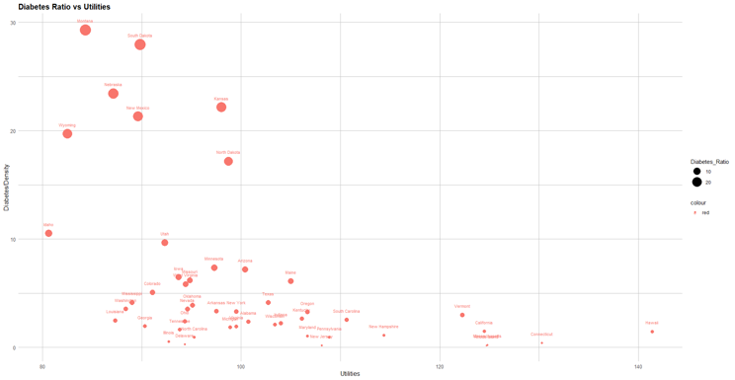
Figure 9: Box plot variables vs diabetes
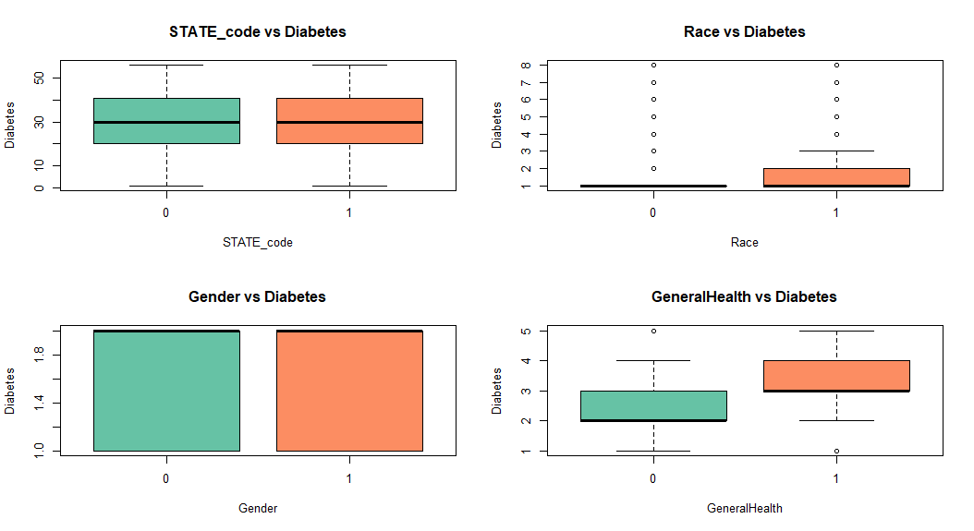

Table 1: Variables Description and values
Variable | Description | Values
General Health | Would you say that in general your health is | 1: Excellent, 2: Very good, 3: Good, 4: Fair, 5: Poor
Physical Activity | Adults who reported doing physical activity  or exercise during the past 30 days other than their regular job | 1: Had physical activity or exercise  2:No physical activity or exercise in last 30 days
Employment | Employment | 1: Employed, 2: Self-employed, 3: No work >1 y, 4: No work <1 y, 5: Homemaker, 6: Student, 7: Retired, 8: Unable to work
Children | How many children less than 18 years ofage live in your household? | 1 - 87 Number of children, 88 None
Alcohol | Adults who reported having had at least  one drink of alcohol in the past 30 days | 1: Yes, 2: No
Health Insurance | Respondents aged 18-64 who have any form of health insurance | 1: Yes, 2: No
Kidney | Ever told you have kidney disease? | 1: Yes, 2: No
Age | Six-level imputed age category | 1: Age 18 to 24 ,2: Age 25 to 34,3: Age 35 to 44  4 Age 45 to 54, 5: Age 55 to 64, 6: Age 65 >=
BMI | Computed body mass index categories | 1: Underweight, 2: Normal Weight ,3: Overweight,  4: Obese
Routine Checkup | Length of time since last routine checkup | 1: Within past year (anytime < 12 months ago)  2: Within past 2 years (1 year but < 2 years ago)  3: Within past 5 years (2 years but < 5 years ago)  4: 5 or more years ago  8: Never
Blood Pressure | Ever Told Blood Pressure High | 1 Yes  2 Yes, but female told only during pregnancy  3 No  4 Told borderline high or pre-hypertensive or  elevated blood pressure
Cholesterol | Currently taking medicine for high cholesterol | 1: Yes, 2: No
Arthritis | Told Had Arthritis | 1: Yes, 2: No
Education | Computed level of education completed categories | 1: Did not graduate high school  2: Graduated high school  3: Attended college  4: Graduated college
Difficulty Walking | Difficulty Walking or Climbing Stairs | 1: Yes, 2: No
Pneumonia | Pneumonia shot ever | 1: Yes, 2: No
MI | Respondents that have ever reported having coronary heart disease (CHD) or myocardial infarction (MI) | 1 Reported having MI or CHD  2 Did not report having MI or CHD
Income | Computed income categories | 1 Less than $15,000  2 $15,000 to < $25,000  3 $25,000 to < $35,000  4 $35,000 to < $50,000  5 $50,000 to < $100,000  6 $100,000 to < $200,000  7 $200,000 or more
State Code |  | 1-52 of United States
Race | Computed Race-Ethnicity grouping | 1 White only, non-Hispanic  2 Black only, non-Hispanic  3 American Indian or Alaskan Native only,Non-Hispanic  4 Asian only, non-Hispanic  5 Native Hawaiian or other Pacific Islander only,Non-Hispanic  6 Other race only, non-Hispanic  7 Multiracial, non-Hispanic  8 Hispanic
Diabetes | (Ever told) you had diabetes | 1 Yes  2 Yes, but female told only during pregnancy  3 No  4 No, pre-diabetes or borderline diabetes
Gender | Are you male or female? | 1 Male  2 Female

Academic Papers Works Cited:
Deshpande, Anjali D. " Epidemiology of Diabetes and Diabetes-Related Complications." Physical Therapy, Volume 88, Issue 11, 1 November 2008, Pages 1254–1264, https://doi.org/10.2522/ptj.20080020

Hill-Briggs, Felicia et al. “Social Determinants of Health and Diabetes: A Scientific Review.” Diabetes care, vol. 44,1 258–279. 2 Nov. 2020, doi:10.2337/dci20-0053, https://pubmed.ncbi.nlm.nih.gov/33139407/

